**Geometric Abstract Blue Black Yellow Large Wall Art Print**

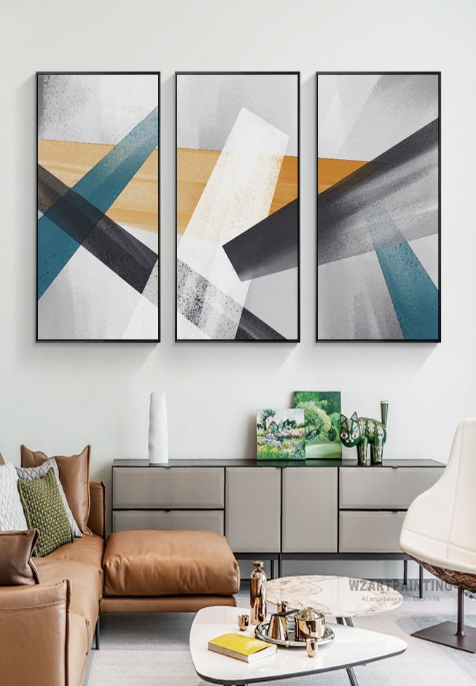Geometric abstract blue, black, and yellow large wall art print is a bold and dynamic piece that combines vibrant color with modern design. Featuring a striking interplay of geometric shapes such as triangles, squares, and circles, this artwork creates a sense of balance and movement. The deep blues and blacks provide a sophisticated, grounding base, while the bright yellow accents inject energy and contrast into the composition. This large wall art print serves as a captivating focal point, perfect for living rooms, offices, or art-centric spaces. Its contemporary, abstract nature adds depth and intrigue to any interior, making it a perfect choice for those looking to add a pop of color and style to their decor.